**Logo Design Process**

* 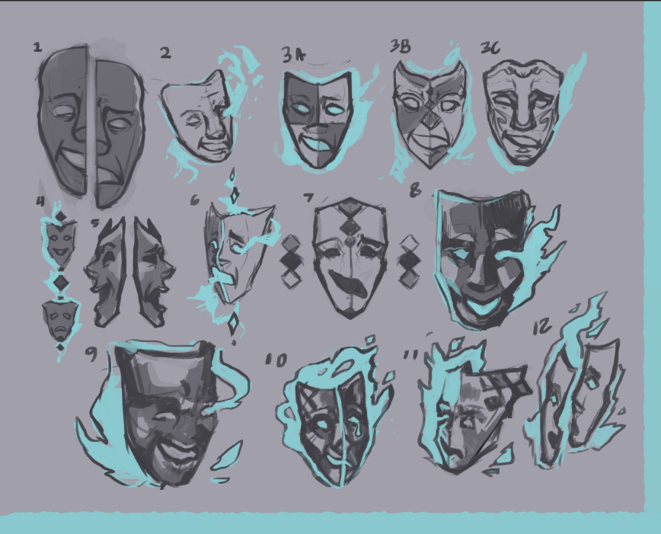We started by discussing concepts for the logo and settled on the idea for theatre masks, liking the contrast between the two emotions.
* I created some initial sketches, and received feedback from my team. Concept 5 and the tear on concept 1 were liked.
* For the first round of iterations, I focused on the concept of 5 and also experimented with the idea of 1, and began thinking more about contrast and color palette. My team liked 1A, 1C, 2A, 2C, 3A, and 3B.

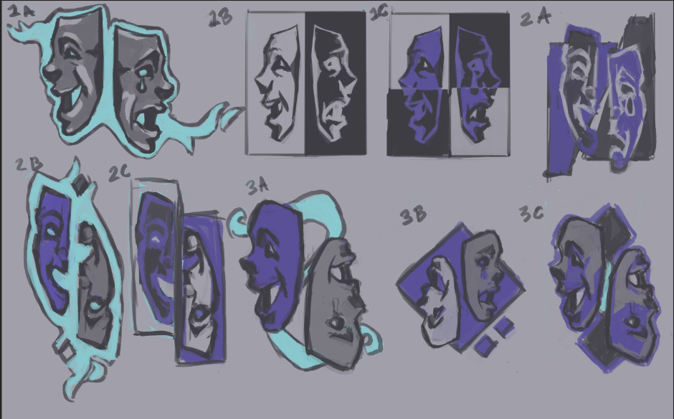

* I narrowed the concepts down to 1C, 2C, and 3B because of their limited color palette and compact design, and selected 1C to refine into the first version of a finalized logo:

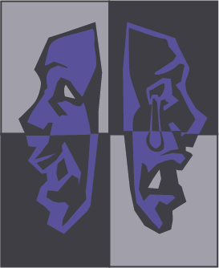

**Page Layout—First iteration**